|  |  |  |  |  |  |  |  |  |  |  |  |  |  |  |
| --- | --- | --- | --- | --- | --- | --- | --- | --- | --- | --- | --- | --- | --- | --- |
| **MAD Project Evaluation 2 – June Intake 2022** | | | | | | | | | | | | | | |
| **Project Name:** |  | | **Batch:** |  | | | |  |  |  |  | | |
| Student ID | Student Name | Integrated system using a repository (Out of 5) | Marketing the app using a video clip published in a social media account (eg: LinkedIn) (Out of 10) | CRUD Function completeness (Out of 20) | Database connectivity (Out of 5) | Usability (Out of 5) | Validations (Out of 5) | Good coding practice (Out of 5) | Out of box features (Out of 10) | Test cases (Out of 10) | Report (Out of 10) | Q & A (Out of 15) | Total (Out of 100) |
| IT20299552 | Rubasinghe L.M |  |  |  |  |  |  |  |  |  |  |  |  |
| IT20605902 | Samarasinghe S.D |  |  |  |  |  |  |  |  |  |  |
| IT20604844 | W.G.T.D Thilakarathna |  |  |  |  |  |  |  |  |  |  |
| IT20607678 | Senevirathne W.S.M.S.D |  |  |  |  |  |  |  |  |  |  |
|  |  |  |  |  |  |  |  |  |  |  |  |

https://github.com/SDSamarasinghe/Top_Jobs_Crooby_Beans

Git Repository Link: ………………………………………………………………………………………………………………………………………………………………………………………………..

https://www.linkedin.com/posts/lalindu-m-rubasinghe-48920a212_android-androiddevelopment-java-activity-6929113398903267328-2hzK?utm_source=linkedin_share&utm_medium=member_desktop_web

Link for the video in social media: ……………………………………………………………………………………………………………………………………………………………………………

(All group members must be tagged)

----------------------------------------------------------------------------------------------------------For Evaluators---------------------------------------------------------------------------------------------------------

Evaluator’s name:

Comments:

1. **Introduction to the Project**

In the modern world everyone is undergoing busier lives than ever. People do not have time to read newspapers and random websites to search for job opportunities. And they are going to smart world day by day. To overcome this problem, we are going to create “TopJobs” android app. This will be a free job vacancy app which is mainly designed to help who are looking for a job in IT field. Also, the companies that offer jobs can find employees with required qualifications using “TopJobs” app.

Users can simply register for the app, and they can find their dream jobs in all career levels, part time jobs and internships in an easy and convenient way through this app whether you are a fresh graduate or an experienced professional. It can be used to keep an eye on the employment market even once you have found an employment. It will keep you up to date with the changing job market and never let you miss your next best career. If you are searching for a job the home page of the app will help you to find a job. If you find the jobs, you need you can contact the company and apply for the job by a simple touch of a button.

Do not close the app if you did not find the required opportunity, you can post a job request. You can market yourself by adding your educational qualifications, experience in the field and other qualifications to the job request. You can attract the world's best companies in the IT field anytime anywhere. While you are scrolling through the job vacancies, finding one and planning to apply for it later you can save it for future reference and apply when you are free. It is specifically designed to minimize misplacing your job advertisements.

If a company is seeking for an individual with the necessary skills to hire, they can post a job advertisement to find a suitable candidate from the millions of qualified job finders all over the world. We do not mind if you are a brand-new startup or a historical company, the app is open for everyone. Anyone can use this app easily.

1. **Functionalities**

IT20299552 – Home Page, Edit Requested Job, My Requested Jobs, View a Posted Job, My Saved Requested Jobs and Search Jobs

Crud Operations

After loading the app anyone of the user who use our application can visible the **Homepage** of the app, when the user comes to homepage at any time homepage displays a welcome message like “Welcome to TopJobs “.

However, users can visit posted job opportunities without registration or login. Users can scroll through the job opportunities to find what are the job opportunities they want.

Also, they can **View Jobs** by taps on company icon or job title without login. **(Read)**

For all the other functionalities user must need to register to app and login.

To go to the **My Requested Jobs** Page user must login to the system, then he can tap on the navigation bar and select the My Requested Job category, then user can see what the jobs are he requested. **(Read)** and he can tap on the displaying label, then he redirects to another page and then he can see edit button, when the user taps on edit button, he redirects to **Edit Requested Job** page and now he can edit details he provided to the app when he requested a job. **(Update)** In the edit, user cannot empty required fields such as Job Title, Name, Age, and Description. Also, the user cannot enter above or less than 10 digits for a phone number field and he needs to provide valid email address.

If the user fails to provide valid details the app will prompt warnings and error messages such as “Required Field”, “Invalid Input”.

Users can go to **Requested Jobs** and **save** Employees according to their company or personal requirements. Then he can access the **Saved Requested Jobs** by tapping on Saved Requested Job category in the navigation bar when he taps on it, user redirects to page and user can see what the jobs are he saved from requested jobs list. User can delete Saved Requested Jobs from the list. **(Delete)**

Search added Jobs by Keywords **(Search)**

Home Page

****

My Requested Jobs

Edit Requested Job

View a Posted Job

Saved Requested Jobs

Test Cases

* Only Logged Users can go to the My Requested jobs.
* If the user is not logged in, show a Toast message "Please Login First" and redirect to the login page.
* User can not keep empty input fields of the Edit Request Jobs form. And the form has email validation and phone number validation.

IT20605902 – Create New Jobs, Edit/Delete Profile, Request a Job, View of Requested Job and Calculate the number of Saved Requested Jobs

Crud Operations

After login user can create jobs and publish it as an advertisement. User can go job listing page and click “Create new Job”. This interface has 10 components. 9 components are text and top down and other one is added image component. If user is already registered this system. User will redirect to the listing jobs. Otherwise, user will automatically redirect to the login page. User must fill all these things. **(Create).**

In the profile page user can view their details on the page and if user want change values in the profile. **(Read)** He/she can press Edit button and user will be navigate to another UI. It contains similar component as previously. Now user can change values using edit text boxes and drop-down list**. (Update**) Also user can delete his profile, if he thinks he wants**. (Delete)**

User can go to the My Requested jobs page by pressing the “My Requested Jobs” button in the navigation menu. It also same as My Job Listings page and there are job requests that users made and there is a button called “Request New” to go to the Request a job page. In the Request job page, I have implemented some component using text box, spinners, and buttons user can request a new job after filling all these details. He / She cannot press “REQUEST” button without filling any of this fields**. (Create).**

Calculate the number of Saved Requested Jobs **(Calculation)**

User can go “My requested Jobs” through navigation bar. Then user can view all the requested jobs. If user want to see further details of that job, he/she can visit the view of that page click on it**. (Read)**

Create Jobs

Profile/ Edit Profile

Request a Job

View Requested Job

Test Cases

* In the Create Jobs page & Create Requested Jobs page if the user keeps blank in any input fields a validation message appears that it is required.
* In the Edit Profile page if the user keeps blank in any input fields a validation message appears that it is required.
* In the Edit Profile page in the user cannot exceed 10 numbers or cannot keep less than 10 numbers in the contact number input fields it appears a validation message appears that Invalid Phone Number.

IT20604844 - User Login, User Registration, Edit and Delete Created Job, Salary Calculate, View Saved Job List

Crud Operations

After the loading the application user must login to the system to access the functionalities. Then the user wants to tap on the login button in the navigation bar.

When user taps on the login button app will redirects to sign in page and user enter valid user credentials after clicks on sign in button and if the username and password match the user authorized and granted access to the app otherwise the login attempt will be rejected. If the login is successful app will display a message as “Login Successful” and app will redirect to user select functionalities. (**Login Validation**)

If user have not registered to the system first, he or she wants to sign up to the system. It only asks for a name, email, phone and password and confirm password. This interface form contains form validation methods. Multiple accounts for the same email address are not allowed. After the sign-up user can login to the app using his credentials**. (Create)**

Job creator can edit jobs taps on edit button in edit created job page and he can edit job details he provided to app when he or she created job. **(Update)**

This interface form contains form validation methods so job creator cannot empty required fields such as “job title”, “company name” etc. If the job creator fails to provide these requirements app will provide warnings and error messages as “Require Field”, “Invalid input”.

Job creators want to remove previous created jobs from the system delete button in edit job page will lead to that. **(Delete)**

User can go to the saved job page and user can read all of the data in there by using database **(Read).**

Job finder can calculate salary by using “My Salary Calculator” and enter salary ranges offered by companies and calculate the salary of their dream jobs. (**Calculation**)

User Login

User Registration

Edit / Delete Created Job

View Saved Jobs

Test Cases

* In the registration page if the user keeps blank in any input fields a validation message appears that it is required.
* If the user enters a password less than 6 characters a message appears with text **“Password must be greater than 6 characters”** and Password and Re-enter passwords must be same.
* Email field has an input validation and phone number field has a validation.

IT20607678 – Save Jobs, Delete Saved Jobs, My Job Vacancies, Requested Jobs, Navigation Bar and Calculate the number of Saved Jobs

Crud Operations

After login to the application, user allows to find the suitable jobs for their qualification and can save (**Create**) favorite job advertisements. After saving the favorite job advertisements they all can view by clicking on "My saved jobs" in the menu button. And user can remove (**Delete**) the saved ones by clicking on removing icon.

After login into the application, user can display the home page of the application. There is a menu button in the left corner of that page. By clicking the menu button gives user a navigation bar. The navigation bar is included with buttons to the profile and logout, Home Page, My Jobs Vacancies, Saved Jobs, Requested Jobs, Saved Requested Jobs and Calculate Salary button.

By clicking on the "profile icon " its redirect the user to the profile page. There is a "logout" button in the upper right of the corner of the navigation bar to logout from the current profile.

user can click on the "My Job Vacancies" and its redirect user to the My Job Vacancies page. “My Job Vacancies" page consists of the job advertisements that user created.by click on advertisements user can view the full details. (**Read**)

user can see (**Read**) all the requested jobs list by clicking on the "requested jobs" button in the menu bar.

Calculate the number of saved jobs (**Calculation**)

Saved Jobs

Requested Jobs

My Job Vacancies

Navigation Bar and Calculate the number of Saved Jobs

Test Cases

* Only Logged Users can click on My Job vacancies, Saved Jobs, My requested Jobs, Saved Requested Jobs and go through them, but other unlogged users can access Home Page and Requested Jobs through the navigation bar.
* If the user is not logged in, show a Toast message "Please Login First" and redirect to the login page.
* If there was Database Error
* Show Toast message “Database Error try again" for user.

1. **GitHub Commit Graphs**

Our master branch is not working, because of that we created another branch called “feature/development” and use it as the base branch.

1. **Individual Commits**

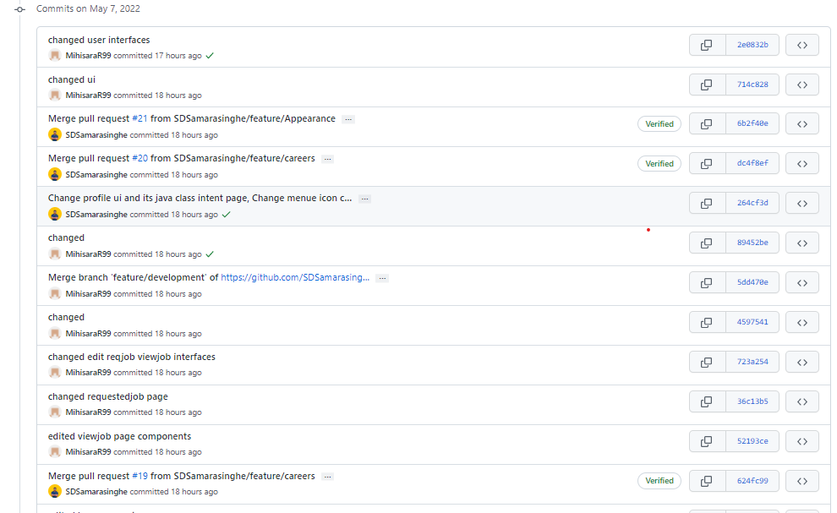

**(After going through the evaluation phase 1, we did some changes to our user interfaces and changed our color theme.)**